The Perfect Gift

**Team Members:** June Etyang, Mary Wamaitha, Prudence Wangari

Audrey Obuobisa-Darko

URL:

[smartteachhub.000webhostapp.com](https://smartteachhub.000webhostapp.com/)

Table of Contents

Business Overview and Objectives 3

Business Model Plan 3

System Analysis & Planning 7

User Flow Diagram 9

Pseudocode 10

Database 11

Entreprise Rules 13

N-Tier Architecture 14

Testing 15

Figma Prototypes & Functionalities 16

Member Participation 18

# Business Overview and Objectives

Realise how difficult it can be sometimes to find the perfect gift for your loved one? Even when you do, where do you find it? Look no further than The Perfect Gift. The Perfect Gift is an e-commerce solution that generates gift product/service ideas perfectly tailored to customers (for purchase), according to the gift-receiver’s personality and preferences. Customers can reach a wide variety of products all in one place, and can also purchase generalised products. It also provides an opportunity for wholesalers of gift items to reach a large customer base and expand their businesses.

Some of the products that we offer are T-shirts, coffee mugs,cards, drinking games, notebooks, journals, gratitude jar, polaroid pictures, stickers and pin-back buttons. The business currently operates in Ghana but would like to expand to the West-African market in the next 10 years.

# Business Model Plan

**Value Proposition**

Headline: Your partners in ensuring you get the perfect gift, every time, on-time, for everyone that matters, for every occasion.

Sub-headline: We understand that you want to get a birthday card with an inside joke for your best friend’s birthday or a football-based tea-mug for your partner. However, the process of getting such customized gifts often requires long search-times trying to get a brand that guarantees quality, multiple back and forth WhatsApp messages and unclear pricing structures. Perfect Gift is here to ensure that from now on, you can easily order and get a customized gift for all your special gifting needs with just a few clicks and with every process you will know exactly when the gift will be ready and how much it will cost you.

# Revenue Model

The company’s revenue model is a sale of goods model where the company makes money from selling the products on the site.

The company’s business model is a virtual merchant where all the buying and selling happens online.

The following are how much we are planning to price our items

|  |  |
| --- | --- |
| Generic item cost ( cedis) | Customised Item Cost (cedis) |
| Coffee mugs - 60 | Coffee mugs - 75 |
| Cards (birthday, wedding, thank-you and all | Cards (birthday, wedding, thank-you and all |

|  |  |
| --- | --- |
| other types) - 25 | other types) - 30 |
| Tshirts - 50 | Tshirts - 65 |
| Gratitude Jar - 35 | Gratitude Jar - 50 |
| Journals - 50 | Journals - 60 |
| Stickers - 10 | Stickers - 15 |
| Drinking Games - 70 | Drinking Games - 100 |
| Notebooks - 50 | Notebooks - 70 |
| Polaroid pictures - 30 | Polaroid pictures - 50 |
| Pin-back buttons - 10 | Pin-back buttons - 12 |

# MARKET TRENDS

Market opportunity refers to our company's market space with potential financial opportunities available to the firm and the customers. The secret to love is kindness which can be shown by giving gifts to loved ones as a form of appreciation. As such, we did the following analysis for our market:

# Market Trends

Retail Gift Shops are evolving due to the introduction of technology as they can effectively predict consumer demand patterns and changing preferences to meet the needs of customers. Hence the Perfect Gift shop is no longer limited to a single customer or women because the market has expanded thus improving the overall performance in this industry.

# Our Target Market

Our business is an online shop for gift products and a delivery business hence the need for a wide range of available customers. We are primarily focused on customers within the same geographical location as follows:

* Students
* Businesspeople
* Corporate organizations
* Tourists
* Everyone who resides within our location

# Main Competitors

Refers to other companies selling similar products and operation in the same market space, presence of substitute products and potential new entrants to the market.

Direct competitors are companies that sell products and services that are very similar and into the same market segment. Some of our direct competitors include:

* IMPRESSIONS GIFTS AND HAMPERS, Ghana – who make unique breakfast and lunch baskets for birthdays and other occasions for groups. They are into wrapping and packaging for engagements, customized gifts, and hampers for birthdays
* Lotus Gallery – they are a lifestyle gift shop that offers products and services that match every kind of budget and preference of clients with customized printing and wrapping services.
* Odo Asem Shop – they have in stock various gift choices which are well selected for special occasions ranging from games, books, toys, and lingerie.

Indirect competitors are companies that may be in different industries but still compete indirectly because their products can substitute for one another. For instance, we have supermarkets as competitors. Customers may go to shopping stores and purchase items such as mugs and cards.

# Comparative Advantage

The Perfect Gift is able to produce excellent gift items and services at a cheaper cost than other competitors, through striking partnerships with gift item manufacturers at the source, forming close relationships with suppliers, and incurring low opportunity costs. This will enable The Perfect Gift to gain stronger sales margins and greater profitability.

# Market Strategy

Leveraging on the 5 P’s of Marketing – Product, Price, Promotion, Place, and People, we intend to reach prospective consumers and convert them into customers by offering attractive pricing terms such as discounts, bonuses, and promotions every now and then. Promotion strategies to enter the market will include influencer marketing and sponsorships, and persuasive public relations to position the business. Forming close relationships with customers and frequently taking and implementing feedback will help convert one-time customers into long standing customers.

# Organizational Structure

The business has different departments to ensure that all the necessary operations run smoothly. The main departments are: production team in charge of acquiring the gift sets and customizing them, the sales team in charge of brand management and advertising and finally the technical team in charge of managing the website and other crucial back end operations. All the departments are required to work together to ensure smooth flow of work.

# Management Team

The company needs a strong management team which will be responsible for making sure all the departments work together. At the top level, we have the manager who is in charge of making executive decisions and the departmental heads report to the manager. AT the departmental level, we have the heads in charge of each department to ensure that everyone does their work accordingly and keeps track of all the activities. Everyone in the team is given their roles based on their expertise. This is to ensure that everyone's best skills are applied to the work to increase efficiency and have quality results for every task that is done in the company.

# System Development Life Cycle (Design and Architecture) Systems Analysis/ Planning

|  |  |  |
| --- | --- | --- |
| **Business Objectives** | **System Functionalities** | **Information Requirements** |
| Personalise gift orders | Filtering by keywords detected, SEO elements for products, User on-site tracking | Keywords; product details/description, website log to track user behaviour |
| Display gift items | Digital catalog of pictures/videos | Dynamic text and graphics catalog |
| Categorise gift items | Category pages, categorisation schemes, SEO elements for products, navigation feature | Keywords; product details/description |
| Search gift items | Search engine, filtering by keywords, auto-complete, drop down list | Keywords; product details/description |
| Display product information | Database of product information | Product details eg. brand, dimensions, colour, quantity |
| Provide wrapping/ packaging services | Wrapping/packaging options database | Product details eg. wrapping material, dimensions, colour, quantity |
| Provide gifting tips and ideas | Banner and carousel manager | Dynamic text and graphics catalog |
| Gather customer details | Database of customer information | Name, phone number, email, address, payment details |
| Execute online transactions and issue invoices | Shopping cart, payment system (e.g. integrating Paystack) | Payment options eg. mobile money, VISA card; payment details, secure card clearing |
| Upload products, track inventory | Dashboard; inventory management system | Stocking numbers, inventory levels |
| Track sales, revenue, profit, etc. | Sales and revenue analytics system | Number of purchases, unit prices, expenses, etc |
| Offer customer support | Auto-email, phone call | Customer details eg. name, |

|  |  |  |
| --- | --- | --- |
|  | manager, customer database | phone number, Customer ID |
| Marketing and advertising | Marketing automation system, email marketing campaign manager, eg. Mailchimp, ad banners | Customer details eg. email; website log tracking customer behaviour |

**Systems Design**

User flow diagram

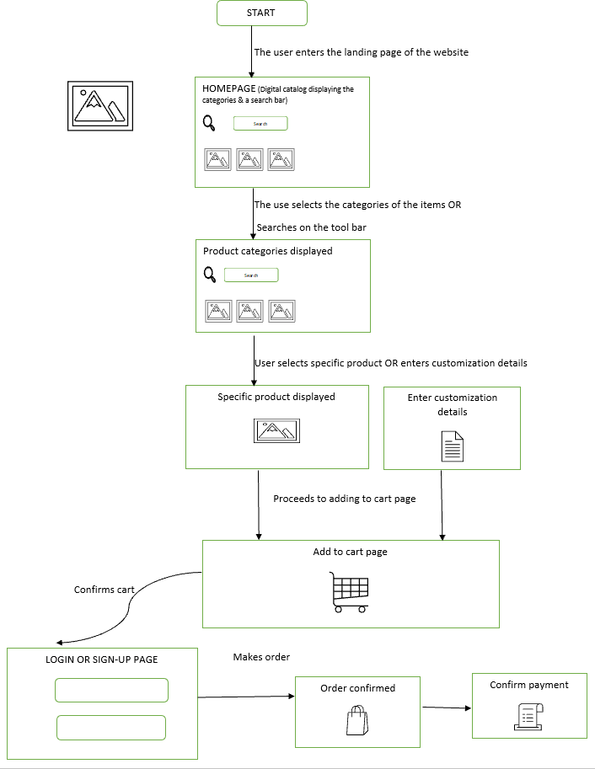

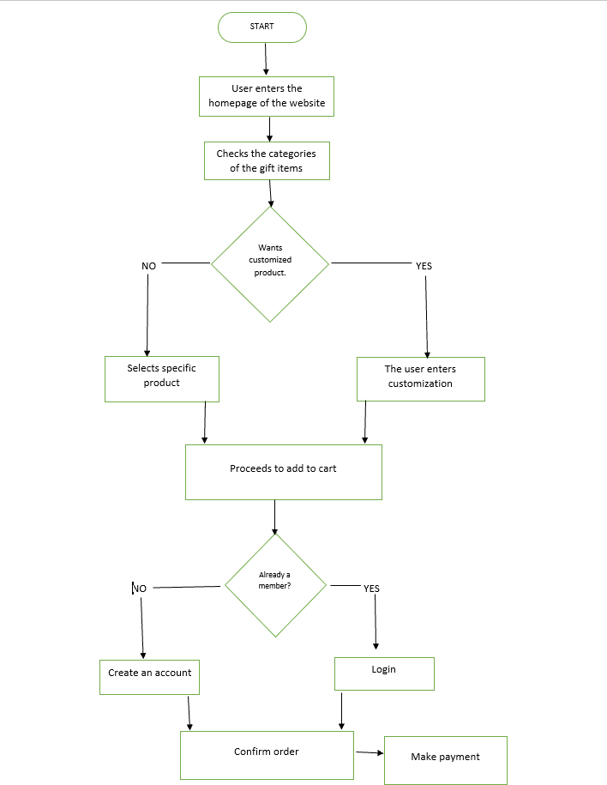Pseudocode

# DATABASE

**Db name: perfect_gift**

CREATE TABLE `customers` (

`customer_id` int(11) NOT NULL,

`customer_Fname` varchar(100) NOT NULL,

`customer_Lname` varchar(100) NOT NULL,

`customer_email` varchar(50) NOT NULL,

`customer_pass` varchar(150) NOT NULL,

`customer_contact` varchar(15) NOT NULL,

) ENGINE=InnoDB DEFAULT CHARSET=latin1;

CREATE TABLE `categories` (

`category_id` int(11) NOT NULL,

`category_name` varchar(100) NOT NULL

) ENGINE=InnoDB DEFAULT CHARSET=latin1;

Indexes for table `categories` ALTER TABLE `categories`

ADD PRIMARY KEY (`category_id`); Indexes for table `customers`

ALTER TABLE `customers`

ADD PRIMARY KEY (`customer_id`),

ADD UNIQUE KEY `customer_email` (`customer_email`);

AUTO_INCREMENT for table `categories` ALTER TABLE `categories`

MODIFY `category_id` int(11) NOT NULL AUTO_INCREMENT, AUTO_INCREMENT=3;

AUTO_INCREMENT for table `customers` ALTER TABLE `customers`

MODIFY `customer_id` int(11) NOT NULL AUTO_INCREMENT;

Customers (CustomerID, f_name, l_name, email, password, Phone, Address) - Prudence

Categories (CategoryID, CategoryName) - Prudence

Products (ProductID, ProductName, Price, Picture, Tags, Colour, Description, Status. Quantity) - Audrey

Purchase Table ( Purchase _ID, Product_ID, Quantity)- Wamaitha Cart (Cart_ID, Purchase_ID,Customer_ID, Grand Total) - Wamaitha Delivery Cost ( delivery_id, locations, cost)

Payment (Cart_ID, PaymentID, Date, Total Amount, Ref. ID) - Wamaitha

Admin (AdminLogID, Email, Password) - June

Stock/ Inventory (StockID, ProductID, Quantity, Date, Manager) - June

# ENTERPRISE RULES

* + 1. Customers can buy from zero,one or more products
    2. Products can be bought by zero, one or more customers
    3. Products can belong to multiple categories
    4. A customer can buy from zero,one or more categories
    5. A category can have one or many products
    6. A product can only be in one category

Customer Table

**CustomerID#**, f_name, l_name, email,password, Phone, Address Products Table

**ProductID#,** ProductName, Price, Picture, Tags, Colour, Description, Status. Quantity

Categories Table

**CategoryID#**, CategoryName, *ProductID#,*

Payment

**PaymentID**#, Total Amount, #Cust.ID, #,ProductID, Ref. ID

Admin Login

**AdminID#**, Email, Password

Stock

**StockID#**, ProductID, Quantity, Date, Manager

**Tables from weak entities**

Cart table

*ProductID#, CustomerID#, Total*

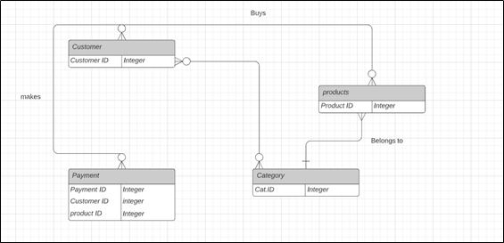

ER Diagram of major entities

# N-Tier Architecture Outline

Front End – HTML , CSS ( Bootstrap frameworks), Javascript ( JQuery Framework) Backend – PHP

Database - PHPMyAdmin

# TESTING

**Unit testing** – testing specific components of the software with the goal to determine those different functionalities are working .Includes:

* Search based on product name, price, and reviews
* Navigation for multipage
* Product Details Page
* Images, price, reviews, delivery, and shipping information
* In-Out of stock
* Check for broken links
* Speed: Slow and unresponsive pages
* Database test records
* Updating of the databases
* Successful money transaction

**System testing-** testing the entire software to evaluate if it has met all the requirements and up to Quality standards. Includes:

* Overall test of the website

**Acceptance testing** – the user gets to test the software to determine if it meets the customer needs to affirm it's ready to be launched.

* Login, Search and select a product, Add to Cart, Make an Order and Pay, Shipping
* Cancel and preorder
* Contact us
* Fill form for customizing gifts

# Implementation and Maintenance

Select a hosting company

Upload the website to the internet/live server to begin having an operational system. We monitor, check, test and repair any problems with the site.

Change and update the content

Perform SEO – update keywords per the needs of the business and the customers Database maintenance as the system grows to accommodate all the customers

# Figma Prototype

Link to Figma board:

https://www.figma.com/file/smx6HUzBUoyEMa229WfHVf/Team-8:-The-Perfect-Gift?node-id= 0%3A1

Illustrations: <https://undraw.co/illustrations> (**download SVG**)

Colours: Text colour #3F3D56 (**it’s not black black**), #40E0D0 (turquoise), #F7A3B1 (pink) Font styles: Rozha One, Roboto

# Functionalities

**Db name: perfect_gift**

1. Database design (age, gender, relationship, tags: sporty, outdoor type, refer to Figma design) - **Friday, 29th October**
2. Login/ signup (ADDING SESSIONS) - **Tuesday, 2nd Nov (June)**
3. Front end (all pages linked to database) - **Wednesday 10th Nov**
4. Quiz functionality -
5. Homepage (Search functionality) -
6. Quiz suggestions page- audrey
7. Order page for quiz side - audrey
8. Generic gifts page (categories like wedding, birthday, filters on items list page) - Wamaitha
9. Order page for generic side (customisation options, packaging option) - Wamaitha
10. Cart page - Wamaitha (adding to cart, viewing items in cart)
11. Checkout, delivery details and payment options page - Prudence
12. Confirm payment page (Paystack stuff) - Prudence
13. Blog page (paste some articles on gifting) - audrey (embed articles)
14. Profile/my account page (my profile details, my orders) - June
15. Admin side: (dashboard, inventory...) - June

*check login/logout when all pages are arranged, at checkout stage

* highlight current page tab

# Pages

Login/ signup pages (admin and customer, button for switching between pages) Quiz form page

Homepage

Quiz suggestions page Order page for quiz

Generic gifts page (categories like wedding, birthday, filters on items list page) Order page for generic side (customisation options, packaging option)

Cart page - (adding to cart, viewing items in cart) Checkout, delivery details and payment options page Confirm payment page (Paystack stuff)

Blog page (paste some articles on gifting) - (embed articles) Profile/my account page (my profile details, my orders)

Admin side: (dashboard, inventory (adding a product), confirming orders...)



# MEMBER PARTICIPATION

1. Mary Wamaitha - Backend, Frontend editing
2. June Etyang - Admin Dashboard, Admin Frontend, Admin Backend
3. Prudence Kariuki - Frontend, Search and Product Detail Display
4. Audrey Obuobisa-Darko - Building Prototype